Types of Predicates
# Source: AI Source: Provided by: [Data Path: Persons Table -> ID Column: 1, Name_En Column: Motasem Essam] -> From: [ChatGPT] on [8/4/2025]
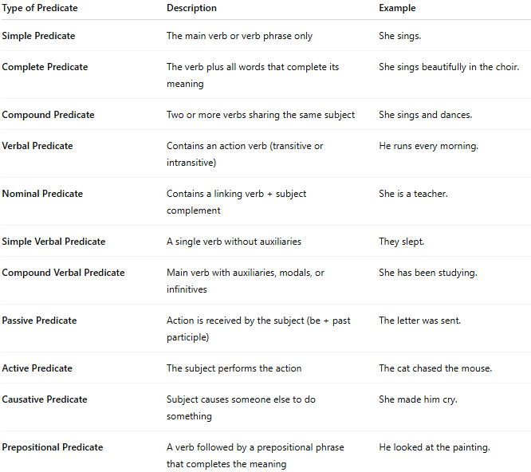

Type of Predicate | Description | Example
Simple Predicate | The main verb or verb phrase only | She sings.
Complete Predicate | The verb plus all words that complete its meaning | She sings beautifully in the choir.
Compound Predicate | Two or more verbs sharing the same subject | She sings and dances.
Verbal Predicate | Contains an action verb (transitive or intransitive) | He runs every morning.
Nominal Predicate | Contains a linking verb + subject complement | She is a teacher.
Simple Verbal Predicate | A single verb without auxiliaries | They slept.
Compound Verbal Predicate | Main verb with auxiliaries, modals, or infinitives | She has been studying.
Passive Predicate | Action is received by the subject (be + past participle) | The letter was sent.
Active Predicate | The subject performs the action | The cat chased the mouse.
Causative Predicate | Subject causes someone else to do something | She made him cry.
Prepositional Predicate | A verb followed by a prepositional phrase that completes the meaning | He looked at the painting.

